Neil Shet
CIS 4374 Information Systems Project Management

Homework 1
Initial Kickoff (Version 1.0)

Vision and Scope
Project Acquisition
$oftware Corp. identified an opportunity to improve urban parking management through a digital platform that provides real-time parking information. The organization selected the Smart Parking Platform project because drivers waste significant time searching for parking spaces, while parking operators often lack efficient tools for monitoring occupancy and managing reservations. The project aims to improve the parking experience for users while increasing operational efficiency for parking facility operators.
Vision Statement
The Smart Parking Platform will provide drivers with a convenient method to locate, reserve, and pay for parking spaces through a web and mobile application. The platform will reduce time spent searching for parking and improve parking facility utilization.
Project Scope
The project includes:
- User account registration and login
- Parking space search
- Real-time parking availability
- Parking reservations
- Digital payment processing
- Navigation assistance
- Notifications and alerts
- Administrative dashboard
- Occupancy reporting and analytics

The project excludes:
- Physical parking garage construction
- Hardware installation within parking facilities
- Vehicle maintenance services
Competitive Analysis
ParkMobile
Strengths:
- Widely used
- Simple mobile payments
- Real-time parking sessions
Weaknesses:
- Limited reservation availability in some areas
- Depends on participating cities
ParkWhiz
Strengths:
- Event parking reservations
- User-friendly interface
Weaknesses:
- Less focus on real-time occupancy data
SpotHero
Strengths:
- Advanced reservations
- Large network of garages
- Price comparisons
Weaknesses:
- Availability varies by city

Opportunity for Differentiation
Our Smart Parking Platform will differentiate itself through:
- Real-time occupancy tracking
- AI-based parking recommendations
- Predictive availability forecasting
- Dynamic pricing suggestions
- Unified mobile and web experience
Stakeholders
Stakeholder | Interest
Drivers | Find parking quickly
Parking Operators | Increase utilization
City Transportation Departments | Reduce congestion
System Administrators | System maintenance
Finance Personnel | Payment processing
Payment Providers | Payment integration

Initial Use Cases
Use Case 1: Register Account
Actor: Driver
Goal: Create an account.
Basic Flow:
- User enters information.
- System validates information.
- Account is created.
Use Case 2: Search for Parking
Actor: Driver
Goal: Find available parking.
Basic Flow:
- User enters destination.
- System displays nearby garages.
- User views availability.
Use Case 3: Reserve Parking Spot
Actor: Driver
Goal: Reserve a parking spot.
Use Case 4: Make Payment
Actor: Driver
Goal: Pay for reservation.
Use Case 5: View Occupancy Dashboard
Actor: Parking Operator
Goal: Monitor garage utilization.
Initial Requirements
Functional Requirements
FR-1: The system shall allow user registration.
FR-2: The system shall display real-time parking availability.
FR-3: The system shall allow parking reservations.
FR-4: The system shall process online payments.
FR-5: The system shall generate occupancy reports.
Nonfunctional Requirements
NFR-1: System uptime must be 99%.
NFR-2: Payment transactions must be encrypted.
NFR-3: Mobile pages should load within 3 seconds.
NFR-4: Platform must support at least 10,000 users.

Homework 2
Deliverables (WBS/Draft Timeline) (Version 2.0)

Work Breakdown Structure (WBS)
1.0 Authentication System
1.1 User Registration
- 1.1.1 Registration Form
- 1.1.2 Account Validation
- 1.1.3 Account Creation
1.2 User Login
- 1.2.1 Login Screen
- 1.2.2 Credential Verification
- 1.2.3 Session Management

2.0 Parking Search and Reservation
2.1 Parking Search
- 2.1.1 Location Search
- 2.1.2 Map Display
- 2.1.3 Availability Display
2.2 Parking Reservation
- 2.2.1 Create Reservation
- 2.2.2 Modify Reservation
- 2.2.3 Cancel Reservation

3.0 Payment Processing
3.1 Payment Integration
- 3.1.1 Payment Gateway Setup
- 3.1.2 Secure Transaction Processing
- 3.1.3 Receipt Generation
3.2 Financial Records
- 3.2.1 Payment History
- 3.2.2 Billing Reports

4.0 Administrative Dashboard
4.1 Parking Operator Management
- 4.1.1 Garage Management
- 4.1.2 Space Availability Updates
- 4.1.3 User Management
4.2 Reporting and Analytics
- 4.2.1 Occupancy Reports
- 4.2.2 Revenue Reports
- 4.2.3 Usage Analytics

5.0 Notifications and Navigation
5.1 Notifications
- 5.1.1 Reservation Confirmation
- 5.1.2 Payment Confirmation
- 5.1.3 Parking Reminders
5.2 Navigation Services
- 5.2.1 Mapping Integration
- 5.2.2 Route Guidance
- 5.2.3 Destination Assistance

Project Schedule

Task ID | Task | Duration
1 | Requirements Analysis | 1 Week
2 | System Design | 1 Week
3 | Authentication Development | 1 Week
4 | Parking Search Development | 1 Week
5 | Reservation System Development | 1 Week
6 | Payment Integration | 1 Week
7 | Administrative Dashboard | 1 Week
8 | Notifications & Navigation | 1 Week
9 | Testing & Quality Assurance | 1 Week
10 | Final Project Review | 1 Week

Dependencies
- System Design begins after Requirements Analysis.
- Authentication Development begins after System Design.
- Parking Search Development begins after Authentication Development.
- Reservation System Development begins after Parking Search Development.
- Payment Integration begins after Reservation System Development.
- Administrative Dashboard begins after Payment Integration.
- Notifications & Navigation begins after Administrative Dashboard.
- Testing & Quality Assurance begins after all development activities are complete.
- Final Project Review begins after Testing & Quality Assurance.

Gantt Chart (Draft)
Task | W1 | W2 | W3 | W4 | W5 | W6 | W7 | W8 | W9 | W10
Requirements Analysis | X
System Design |  | X
Authentication Development |  |  | X
Parking Search Development |  |  |  | X
Reservation System Development |  |  |  |  | X
Payment Integration |  |  |  |  |  | X
Administrative Dashboard |  |  |  |  |  |  | X
Notifications & Navigation |  |  |  |  |  |  |  | X
Testing & QA |  |  |  |  |  |  |  |  | X
Final Review |  |  |  |  |  |  |  |  |  | X

Project Milestones
Milestone 1: Requirements Approved (End of Week 1)
Milestone 2: System Design Completed (End of Week 2)
Milestone 3: Core User Features Completed (End of Week 5)
Milestone 4: Payment Processing Completed (End of Week 6)
Milestone 5: System Testing Completed (End of Week 9)
Milestone 6: Final Project Submission (End of Week 10)

Homework 3
Product Backlog using Trello

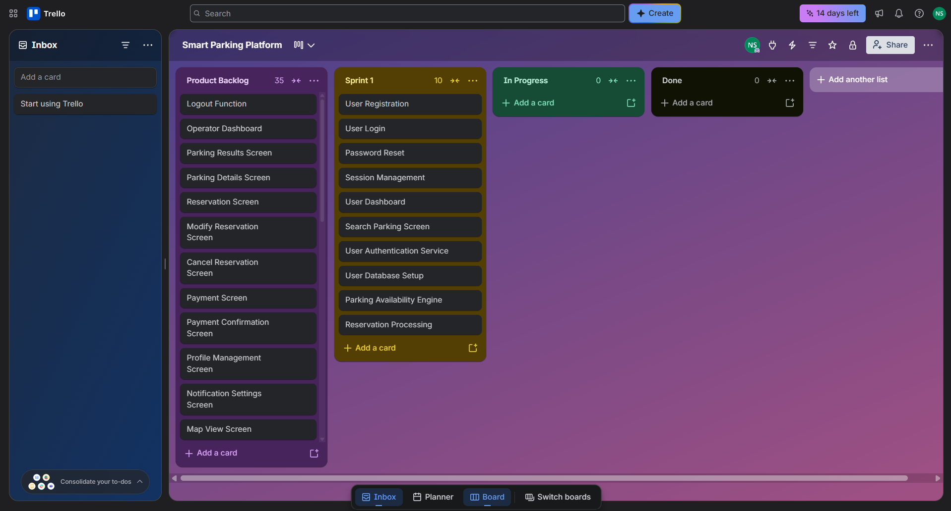

Copilot Office 365 provided by UH was utilized as an analytical tool to assist in organizing data. All final analytical conclusions, evidence verification, source selection, and narrative text were critically reviewed, edited, and approved by the student author.

References
ParkMobile parking app: Find & Pay For Parking: On-Street & Reservation. ParkMobile. (n.d.). https://parkmobile.io/
Find and book parking anywhere. ParkWhiz. (n.d.). https://www.parkwhiz.com/
Get everywhere easier: Reserve parking and save. SpotHero. (n.d.). https://spothero.com/

